Day-23 Lab

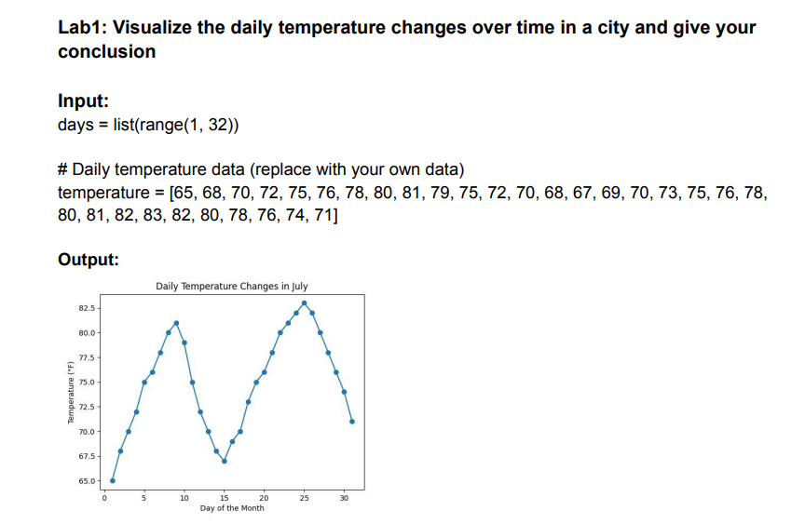

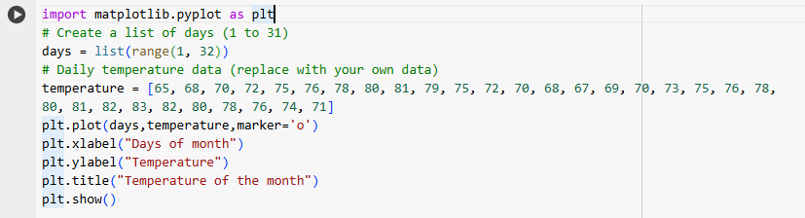

**Conclusion:**

1. **Trend Analysis**:
   * The temperature shows an increasing trend in the initial days of the month, reaching a peak around the 24th–25th day.
   * A slight decline in temperature is observed towards the end of the month.
2. **Daily Variations**:
   * The daily data points (marked with circles) indicate fluctuations in temperature across the month.
3. **Temperature Range**:
   * The temperature fluctuates between 65°F and 83°F, indicating mild to warm weather throughout the month.
4. **Overall Observations**:
   * The temperature steadily increases in the first half of the month, stabilizes in the middle, and gradually decreases by the end.

This kind of visualization is useful for understanding weather patterns and identifying trends over a given period.

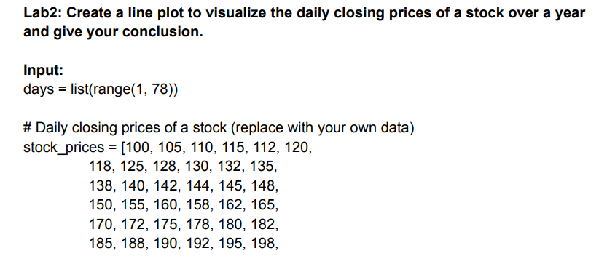

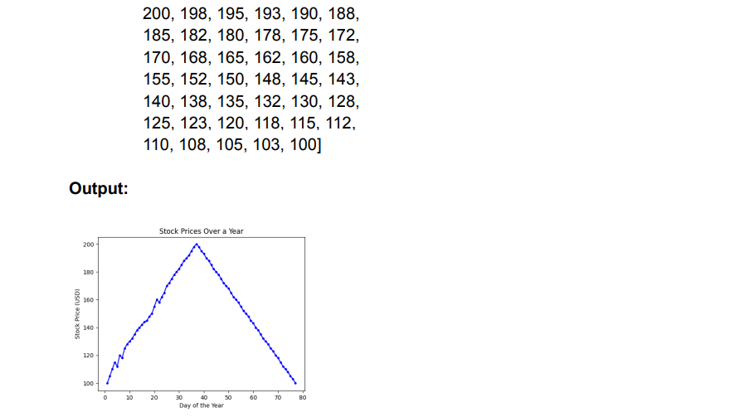

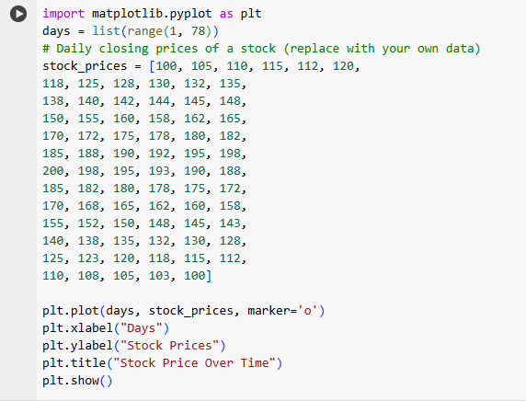

**Conclusion:**

1. **Trend Analysis**:
   * The stock prices show a steady **upward trend** in the first half of the time period, peaking around the middle of the days (approximately day 38).
   * After reaching the peak, the stock prices exhibit a **downward trend**, declining steadily until the last day.
2. **Cyclic Behavior**:
   * The plot indicates a **rise-and-fall pattern** resembling a symmetric cycle. This might reflect a market trend, seasonal behavior, or external influencing factors.
3. **Price Range**:
   * The stock prices fluctuate between **100 (minimum)** and **200 (maximum)** units, with a midpoint (peak price) around day 38.
4. **Overall Observations**:
   * The symmetric nature of the plot suggests a controlled market or specific stock movement with no abrupt volatility.
   * Investors would observe that the peak occurs at a predictable time (approximately halfway), offering opportunities for profit if trading during the upward trend.

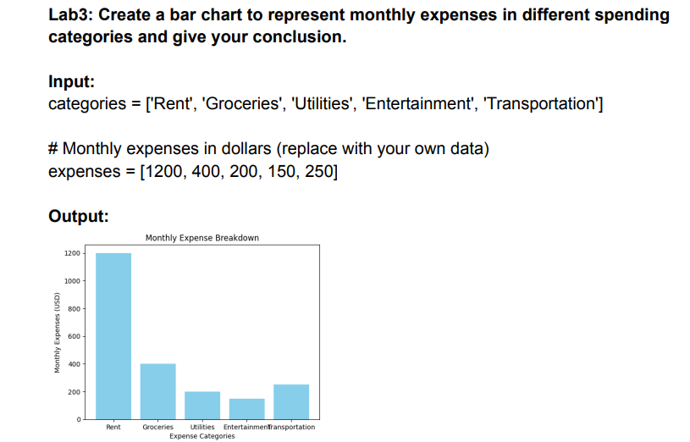

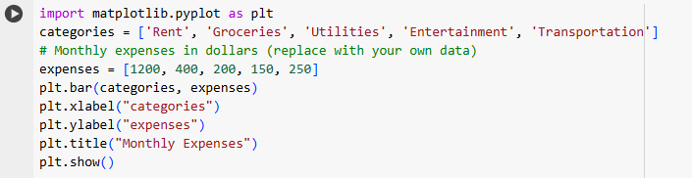

**Conclusion:**

1. **Category Analysis**:
   * **Rent** has the highest expense at **$1200**, indicating it is the major contributor to monthly spending.
   * **Groceries** follow as the second-largest expense at **$400**, which is significantly lower than rent but still a substantial portion.
   * **Utilities, Entertainment, and Transportation** have relatively smaller shares of **$200, $150, and $250**, respectively.
2. **Expense Distribution**:
   * The expenses are unevenly distributed across categories, with a large chunk allocated to rent, which may represent fixed costs.
   * Discretionary spending categories like entertainment have the smallest allocation.
3. **Budget Insights**:
   * The chart provides a clear breakdown of spending, allowing individuals to identify areas for potential cost-saving, such as rent or transportation.
   * It highlights the importance of budgeting higher for essential categories (rent and groceries) while limiting discretionary spending (entertainment).

This visualization effectively communicates how funds are allocated and helps in planning and managing a monthly budget.

Lab4: Create a histogram to represent the distribution of product prices in a retail store and give your conclusion.

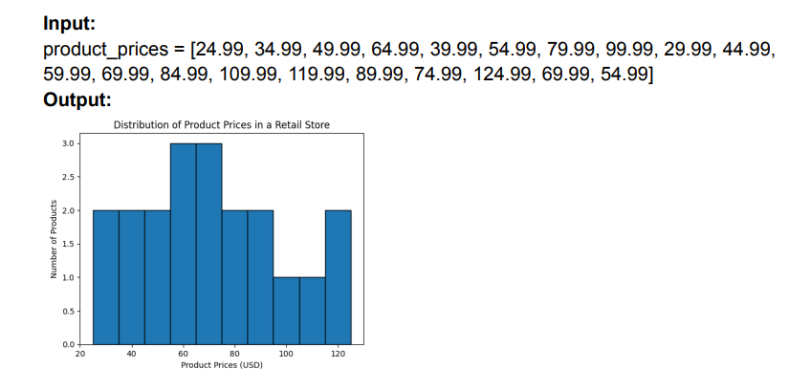

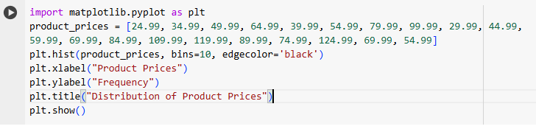

**Conclusion:**

1. **Price Distribution**:
   * The histogram shows how product prices are distributed across various price ranges.
   * Most products fall within a moderate price range (e.g., $24.99–$74.99), indicating a concentration of lower-to-mid-priced items.
2. **Frequency Peaks**:
   * Some bins (price ranges) may have higher bars, representing a higher frequency of products within those ranges. For example, there could be a peak in the $50–$75 range.
3. **Price Ranges**:
   * The histogram highlights the spread of prices from $24.99 to $124.99, with few high-priced items ($100 and above).
   * Products above $100 appear less frequently, suggesting premium pricing is less common.
4. **Business Insights**:
   * This distribution could indicate a focus on affordable and mid-range products, appealing to a larger customer base.
   * Analyzing the distribution helps in pricing strategies, understanding market segments, and adjusting inventory.

This visualization effectively provides an overview of product pricing, enabling businesses to identify pricing trends and potential gaps in their offerings.

